Section 1: Case Summary

Scenario Title: | Nightmares Course: Pneumonia
Keywords: | Pneumonia, sepsis, ventilation
Brief Description of Case: | An admitted patient with community-acquired pneumonia that is resistant to initial antibiotics progresses to sepsis and respiratory failure

Goals and Objectives
Educational Goal: | Identify and treat an unstable ward patient with severe pneumonia
Objectives:  (Medical and CRM) | - Review an approach to the unstable ward patient  - Prioritize the initial investigations and therapies, including ventilatory support  - Review the initial management of the patient with sepsis
EPAs Assessed:

Learners, Setting and Personnel
Target Learners: | ☒ Junior Learners |  | ☐ Senior Learners |  |  | ☐ Staff
 | ☐ Physicians | ☐ Nurses |  | ☐ RTs | ☐ Inter-professional
 | ☐ Other Learners:
Location: | ☒ Sim Lab |  | ☐ In Situ |  |  | ☐ Other:
Recommended Number of Facilitators: | Instructors: 1
 | Confederates: 1
 | Sim Techs: 1

Scenario Development
Date of Development: | 2014
Scenario Developer(s): | Dr Tim Chaplin
Affiliations/Institutions(s): | Queen’s University
Contact E-mail: | chaplintim2@gmail.com
Last Revision Date: | Sept 2019
Revised By: | Suzie Harriman, University of Saskatchewan
Version Number: | 2

Section 2A: Initial Patient Information

- Patient Chart
Patient Name: Jim Smith |  |  |  | Age: 64 | Gender: M | Weight: 85 kg
Presenting complaint: Dyspnea (Admitted with community acquired pneumonia)
Temp: 38.5 | HR:123 | BP: 100/50 |  | RR: 30 | O₂Sat: 89% | FiO₂: 1L NP
Cap glucose: 8.7 |  |  |  | GCS: 14 (E4 V4 M6)
Triage note:
Mr. Jim Smith is a 64yo male that was admitted 3 days ago. He was diagnosed with a community acquired pneumonia and started on Moxifloxacin 400mg PO daily. The nurse is concerned about his increasing shortness of breath over the last 4 hours.

Allergies: NKDA
Past Medical History:  COPD  HTN  CHF  MI |  |  | Current Medications:  Moxifloxacin 400mg PO daily  Bisoprolol 5mg PO daily  Ativan 1mg PO BID prn for anxiety  Atorvastatin 20mg PO daily  Thyroxine 0.1mg PO daily  Dalteparin 5000 U daily

Section 2B: Extra Patient Information

A. Further History
When the learner interviews the patient they will learn that
- They have some pain when taking a deep breath, but mostly finds it difficult to breath
- They have an increasing productive cough, and has not gotten better since admission
- This feels different then a usual COPD exacerbation and “puffers are not really helping”

As interview continues the patient will become more confused and no longer be oriented to person, place and time.

If asked, the nurse can provide additional information including that:
- Cultures were taken and are positive for Pseudomonas aeruginosa which is resistant to Moxifloxacin

B. Physical Exam
List any pertinent positive and negative findings
Cardio: | Neuro: Mild confusion
Resp: Right decreased air entry, crackles | Head & Neck:
Abdo: | MSK/skin:
Other:

Section 3: Technical Requirements/Room Vision

A. Patient
☒ Mannequin - Adult
☐ Standardized Patient
☐ Task Trainer
☐ Hybrid
B. Special Equipment Required
IV (available and present in the patient)
O2 saturation and cardiac monitors
NIPPV
Intubation equipment (Laryngoscope, Bougie, BVM, LMA)

C. Required Medications
Bronchodilators (nebulized and meter-dosed inhalers of albuterol)
Broad spectrum antibiotics (including Ceftriaxone, Piperacillin-Tazobactam)
IV Fluids (Ringer’s Lactate and Normal Saline)

D. Moulage
Mannequin with decreased air entry to right lung, rapid shallow breathing, tachycardia

E. Monitors at Case Onset
☐ Patient on monitor with vitals displayed
☒ Patient not yet on monitor
F. Patient Reactions and Exam
Include any relevant physical exam findings that require mannequin programming or cues from patient
(e.g. – abnormal breath sounds, moaning when RUQ palpated, etc.) May be helpful to frame in ABCDE format.

Decreased air entry to right lung
Speaking in two word sentences

Section 4: Confederates and Standardized Patients

Confederate and Standardized Patient Roles and Scripts
Role | Description of role, expected behavior, and key moments to intervene/prompt learners. Include any script required (including conveying patient information if patient is unable)
Ward Nurse | The ward nurse present in the room should have a headset to allow communication with the control room. They will be the nurse that called the resident to assess the patient and will be familiar with their past medical history and medications. If asked, they will find that the culture results from the sputum sample grew Pseudomonas that was resistant to Moxifloxacin but will not offer this information unless instructed to by the control room. They will generally be helpful and have a knowledge base that is consistent with a nurse working on a medicine ward.

Section 5: Scenario Progression

Scenario States, Modifiers and Triggers
Patient State/Vitals | Patient Status | Learner Actions, Modifiers & Triggers to Move to Next State |  | Facilitator Notes
1. Baseline State  Rhythm: sinus tach  HR: 123  BP: 100/50  RR: 30  O₂SAT: 89% (1L NP)  T: 38.5ºC  GCS: 14 | PT is mildly confused. He is speaking in two word sentences and show signs of respiratory distress | Expected Learner Actions  Perform focused history & PE  Initiate resuscitative measures (IV, 02, monitors)  Ask for appropriate lab work  Ask for ECG/CXR  Check cap glucose  Recognize respiratory failure  Trial a bronchodilator  Plan for ventilatory support | Modifiers  Changes to patient condition based on learner action  - If does give supplemental O2, the patients O2 sats continue to decrease to 82% on RA  Triggers  For progression to next state  - Actions complete or 6 min
2. Resp failure  Rhythm: sinus tach  HR: 123  BP: 100/50  RR: 28  O₂SAT: 92% NRB  T: 38.5ºC  GCS: 14 | Sats improve but pt remains dyspneic and tachypneic | Expected Learner Actions  Identify pneumonia on CXR  Recognize that instability of patient and call Sr resident/staff  Discuss NIPPV and call RT  Recognize shock, start broad spectrum abx (or ask for C+S)  Resuscitate w 2L crystalloid  Consider vasopressors | Modifiers  - BP will decline to 80/40 if no fluids given  - Sats drop to 85% if no NIPPV  Triggers  - All actions complete or 10 minutes
3. Resolution  Rhythm: sinus tach  HR: 110  BP: 120/70  RR: 20  O₂SAT: 94% BiPAP  T: 38.5ºC  GCS: 15 | Patient continues to improve and becomes less confused, less tachypneic | Expected Learner Actions  Discuss and summarize patient’s clinical status and treatment plan with senior resident/staff | Modifiers  Triggers  - Discuss with senior/staff to end case

Appendix A: Laboratory Results – Morning Bloodwork, no new labs available

CBC
WBC 16.2
Hgb 135
Plt 454

Lytes
Na 138
K 3.5
Cl 102
HCO₃ 29
Urea 7
Cr 97
Glucose 6.2

VBG
pH 7.34
pCO₂ 57
HCO₃ 35
Lactate 2.6

Appendix B: ECGs, X-rays, Ultrasounds and Pictures

Paste in any auxiliary files required for running the session. Don’t forget to include their source so you can find them later!

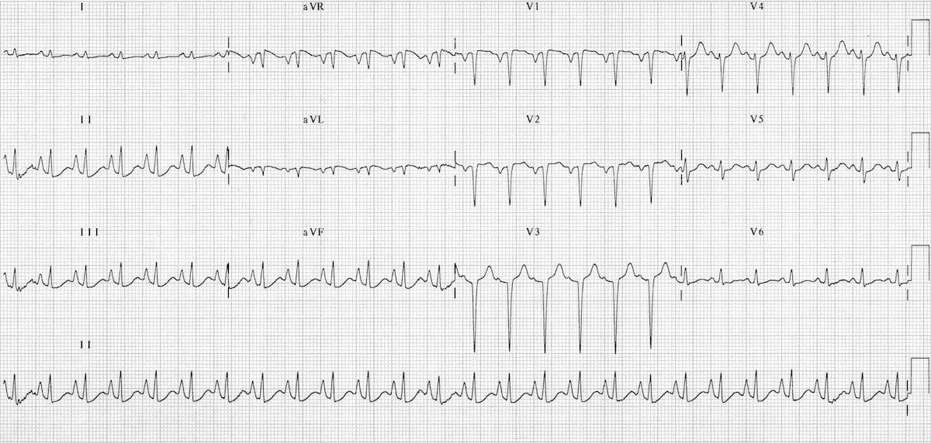
https://litfl.com/ecg-in-chronic-obstructive-pulmonary-disease/

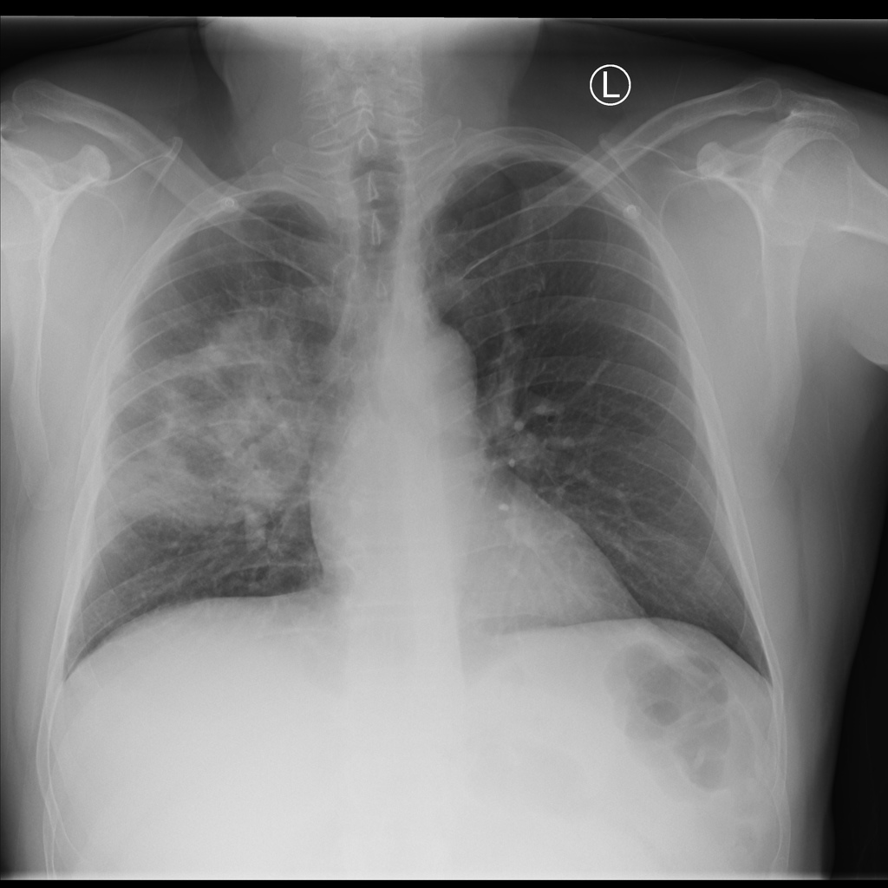
https://radiopaedia.org/cases/right-upper-lobe-pneumonia-8

Appendix C: Facilitator Cheat Sheet & Debriefing Tips

Include key errors to watch for and common challenges with the case. List issues expected to be part of the debriefing discussion. Supplemental information regarding any relevant pathophysiology, guidelines, or management information that may be reviewed during debriefing should be provided for facilitators to have as a reference.

Common Challenges:
- Identifying shock in the setting of respiratory failure
- Differentiating pneumosepsis from COPD exacerbation
- Understanding confusion as multifactorial: poor perfusion/hypoxemia/etc

Debrief Discussion:
- Differential diagnosis of respiratory distress
- Review current sepsis definitions and guidelines for early management
- Clearly communication patient’s clinical state and treatment plan with senior staff

References

1. Surviving Sepsis Campaign: http://www.survivingsepsis.org/Guidelines/Pages/default.aspx
2. Rosen’s Emergency Medicine: Chpts 2, 6, 66, 130
3.

